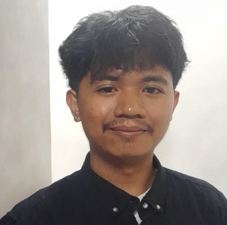
LESTER VILLEGAS DIESTRO
Customer Service Representative

Location: Roxas City, Capiz, Philippines
Phone Number: 09100741140
Email address: lesterdiestro2@gmail.com

Overview: A motivated and enthusiastic individual seeking to start a long-term career in customer service. Although I do not have formal work experience yet, I bring strong communication skills, a positive attitude, and a genuine eagerness to learn and grow. I am passionate about helping people and believe in creating meaningful, solution-focused interactions. My goal is to gain hands-on experience while continuously improving my ability to handle customer concerns efficiently and professionally. I also aim to contribute to the success of the team by maintaining high customer satisfaction, building trust with clients, and supporting the company’s goal of delivering excellent service every time.

EDUCATIONAL BACKGROUND

Bachelor of Science in Information Technology
Filamer Christian University
Roxas City, Capiz, Philippines
Expected Graduation: 2025–2026

SKILLS AND QUALIFICATION

- I’m a fast learner, I am quick to adapt to new tools, systems, and processes
- I have Basic Computer Literacy, I am Familiar with Microsoft Office, email platforms, and internet navigation.
- Willingness to Learn and Grow, I am Open to feedback and always looking to improve.
- I am also a Team Oriented, I Enjoys collaborating with others to achieve shared goals.
- I also have Problem Solving Ability, Able to think critically and calmly in challenging situations.
- Schedule meetings

Here are some of the tools I am familiar with: Social media Tools, (FB, IG, REDDIT, X, TELEGRAM, WHATSAPP, SNAPCHAT, YOUTUBE, DISCORD, TIKTOK) Canva, MS word, MS PowerPoint, Cap cut, meta business, photoshop, GitHub, VScode

